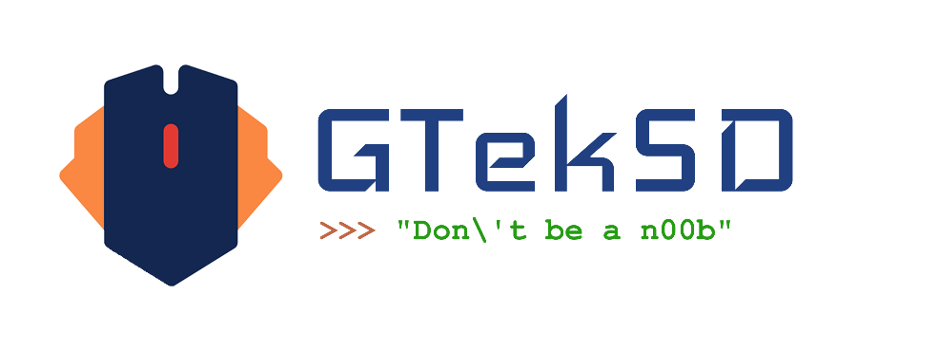

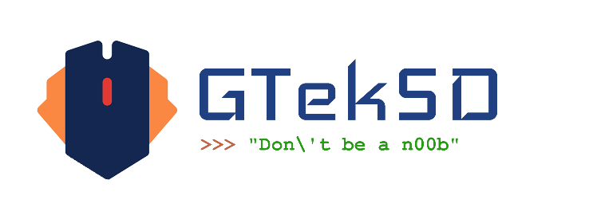

Quotation for Social Media Management Services

Client: **Dr. Firdous Khan**

Agency: GtekSD - The Digital Marketing Solution

Overview

GtekSD proposes to manage the social media accounts of **Dr. Firdous Khan** to enhance online presence, increase patient engagement, and drive new patient acquisition. This proposal outlines the services offered, pricing structure, and additional costs.

|  |  |  |
| --- | --- | --- |
| Service | Description | Price |
| Social Media Account Setup and Optimization | Creation or optimization of social media profiles (Instagram, Facebook, etc.) with relevant information, visuals, and branding elements. |  |
| Content Creation and Planning | Development of engaging content calendar, including informative posts, patient testimonials, before-and-after photos, skin care tips, and promotional content. |  |
| Content Posting and Scheduling | Consistent posting of high-quality content across all platforms, adhering to optimal posting times. |  |
| Community Management | Monitoring and responding to comments, messages, and reviews promptly and professionally. Building and nurturing online community. |  |
| Social Media Advertising | Creation, management, and optimization of targeted social media ad campaigns to reach the desired audience. |  |
| Analytics and Reporting | Regular tracking and analysis of key performance indicators (KPIs) to measure campaign effectiveness. Providing detailed reports on audience demographics, engagement rates, and ROI. |  |
| Social Media Listening | Monitoring online conversations and trends related to dermatology to identify opportunities and address potential issues. |  |

Pricing Structure

Base Package: **₹2969** per month

Includes social media account setup, content creation and planning, posting and scheduling, community management, and analytics and reporting.

Social Media Advertising: Additional charges based on ad spend and platform fees.

Third-Party Tool Costs: Additional charges for the use of paid social media management tools (e.g., Hoot suite, Buffer, Sprout Social).

Note: The exact pricing for social media advertising and third-party tools will be determined based on the client’s specific needs and budget.

Additional Information

Contract Term: 1 month

Payment Terms:

Performance Metrics: Key performance indicators (KPIs) will be established to measure campaign success, such as engagement rate, website traffic, and new patient acquisition.